**Administrator P&T Case Steps and Processes Quick Guide**

**Log-In Instructions**

1. To log-in, go to <https://account.interfolio.com/login> and sign in through the “Partner Institution”

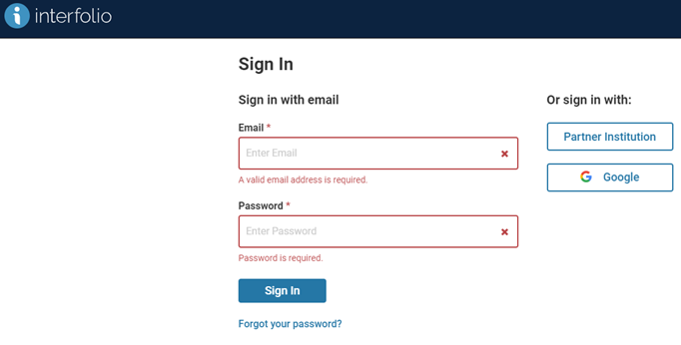

1. “Sign in through your institution” by entering “Texas A&M University” in the search box.

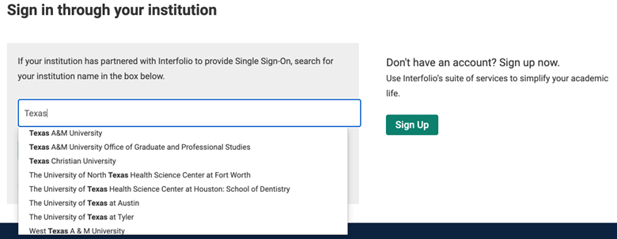

1. Select “Texas A&M University” and then click “Sign In” and login with your TAMU NetID and Password. You will also be required to use the “Duo Two-Factor Authentication” to complete your login. Please note that Google Chrome, Microsoft Edge, Mozilla Firefox, and Safari provide the best browser interface for this application.

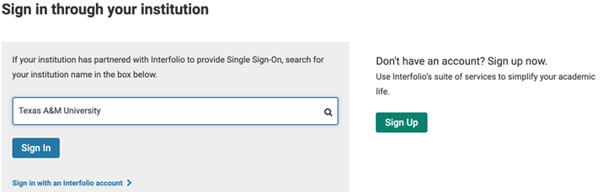

1. Review, Promotion and Tenure (RPT) will appear on the menu on the left side of your screen.

**Creating a Case in Interfolio RPT**

1. Once logged into Interfolio, the left side of the dashboard will have a list of Modules (Faculty180; Faculty Search; Review, Promotion and Tenure) the Administrator has access to.
   1. NOTE: Administrators (department/college level Support Staff, Department Head, Dean) are the only individuals who can create a case!
2. Under Review, Promotion and Tenure click on **“Cases”.**

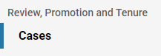

1. Under **“Create Case”** in the upper right corner you can create individual cases (one by one).



1. The screen below should appear.

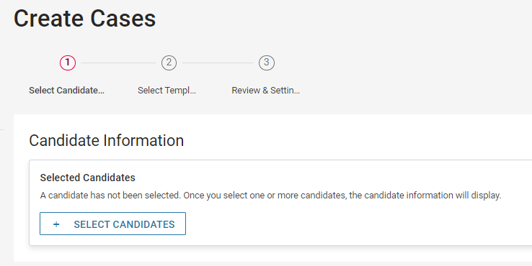

1. To start creating a case for a new Candidate type click the **“+ Select Candidates”** button to begin.



1. If the candidate is already in the list of Texas A&M University **“Users”** their name will appear in the listing. To quickly find your candidate use the search field. Click the magnifying glass to narrow down the candidate list.



1. Click on the checkbox adjacent to the candidate’s name to select the candidate for case creation under the name column. Note, multiple candidates can be created here as well by clicking multiple checkboxes candidates in your respective unit.

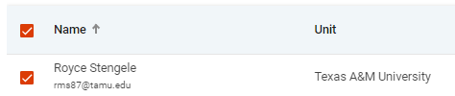

1. Once the candidate’s name is checked, click Add Candidates. On the next screen click **“Continue”** on the bottom left corner



1. A new screen will show up to select your template. For **“Select Case Settings”** make sure to select your **Unit** first and the **Type as Promotion** or otherwise the case cannot be created.

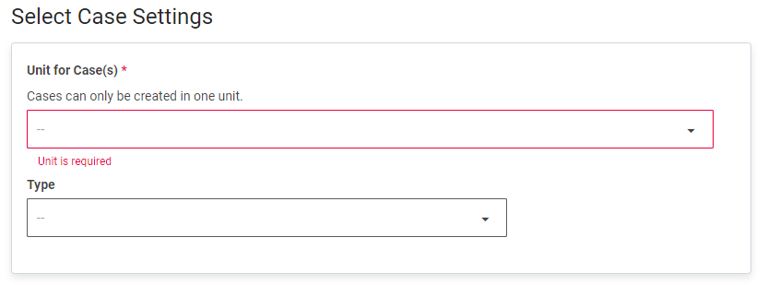

1. On the next screen under **“Select Template”** section, please select **“2024-2025 T-TT Promotion & Tenure”** or **“2024-2025 APT Promotion Template”** under your appropriate unit, which will be named in the **“Unit”** column.
   1. **IMPORTANT**: The Promotion and Tenure template will be for Tenure and Promotion, Tenure only, and Tenured, Promotion only. The APT Template will be for APT Promotion. **Do not select any other templates!**
2. Select the templateby clicking on the bubble (filled in red once chosen) and click **“Continue”**

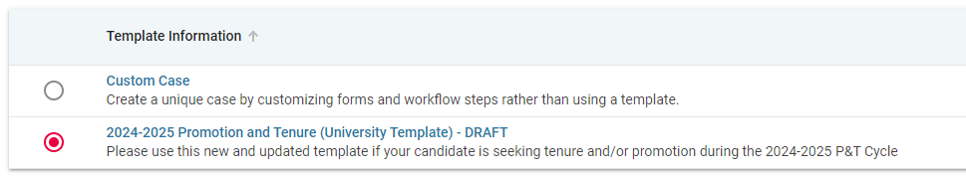



1. Now with the template selected, you will be taken to a new page.
   1. For **“Review & Settings”** the template can be updated regarding a Soft Deadline for the candidate if needed, and the issuances of due dates for Candidate Sections and Case Review steps.
   2. Under **“Candidates”** you will be given the list of candidates that have been chosen to have cases created.
   3. For **“Settings”** there are two yes and no questions to be answered. **“Will the candidate be involved in this evaluation?”** needs to stay marked as **“Yes, the candidate will be involved in the case.”** This is so the candidate can upload dossier items are their own behalf.For **“Would you like to notify the candidates now?”** is defaulted to **“No”,** but this up to the unit’s discretion if they want to notify the candidate immediately upon creation of the case if **“Yes”** is selected. With **“Yes”** selected a new dialogue box appears below the question to inform the candidate of their review.
2. To finalize case creation, click the **“Create 1 Case”** button to create the case. The case will now appear in the “Cases” section of Interfolio RPT.

**Uploading Documents to a “Case”**

1. After you log into Interfolio you will be taken to a Texas A&M branded Interfolio website with all available modules listed on the left side menu
   1. Those who have Committee Manager or Administrator roles can add/upload documents to a case.
2. Under Review, Promotion and Tenure click on **“Cases”.**



1. On the Case list, click the name of the case for which case requires items to upload

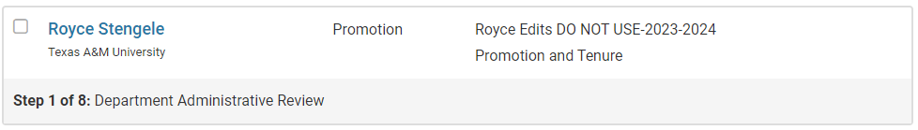

1. On the Case Materials tab, scroll down to “Internal Sections”

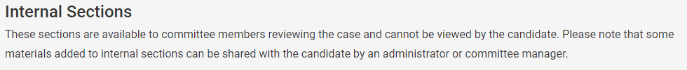

1. Click “Add File” next to the item you are needing to upload your document to.



1. Browse computer to upload appropriate document to the corresponding internal case section.

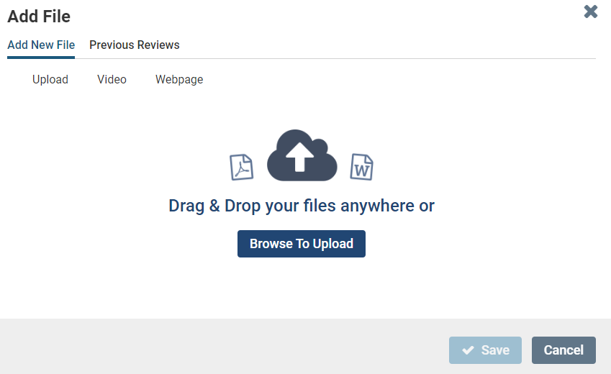

1. Click “Save”

**Sending a “Case”**

1. When inside a candidate’s case, click the **“Send Case”** button at the top right of the page.



1. A drop-down menu will appear to send the case forwards or backwards.
   1. It is recommended to send a message when forwarding the case, so the next level is aware of the submission. Make sure to click the “Send a message to reviewers gaining access” box to do so.

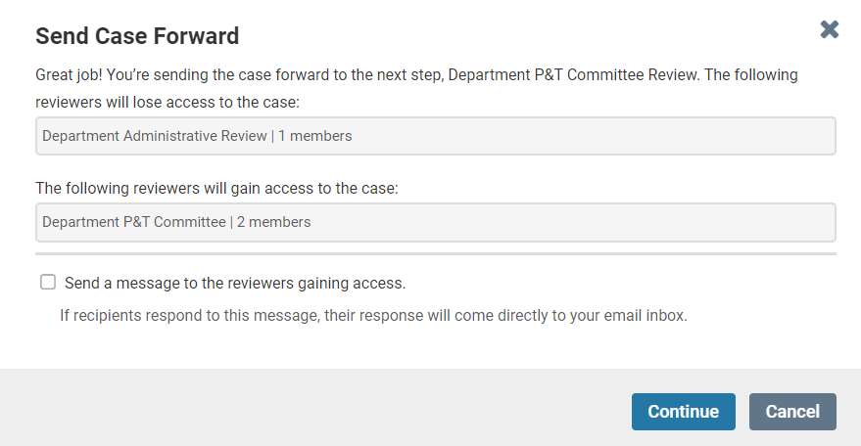

1. Be sure to also update the **“Status”** of the case



**Updating College and Department Committees**

1. Once logged into Interfolio, the left side of the dashboard will have a list of Modules (Faculty180; Faculty Search; Review, Promotion and Tenure) the Administrator has access to.
   1. NOTE: Administrators (department/college level Support Staff, Department Head, Dean) are the only individuals who can create a case!
2. Under Review, Promotion and Tenure click on **“Cases”**   
   

1. Under **“Case Options”** in the upper right corner click on the drop-down menu and select **“Edit Case”.**

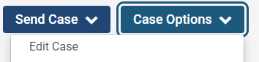

1. On the next screen, click **“Case Review Steps”** on the right side of the screen.
   1. **Note, these next steps will be the same when editing templates as well, if a unit wants to update their template first before creating multiple cases.**

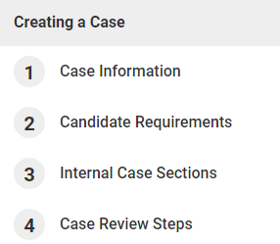

1. This will take you to the **“Case Review Steps”** page where your unit committees, where applicable, can be inserted into the case.
   1. **Make sure to not delete case review steps from the case. The case is in a certain order for Faculty Affairs review.**
2. Click “Edit” next to the respective committee that you want to update.

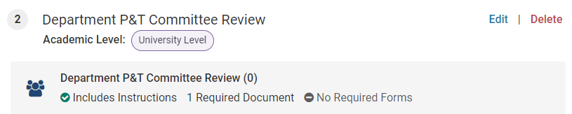

1. Under the **“Reviewers”** section click the **“Options”** button to bring up the drop-down menu. Click **“Replace Committee”**.

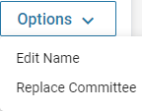

1. After clicking **“Replace Committee”** a new dialogue box will appear below.

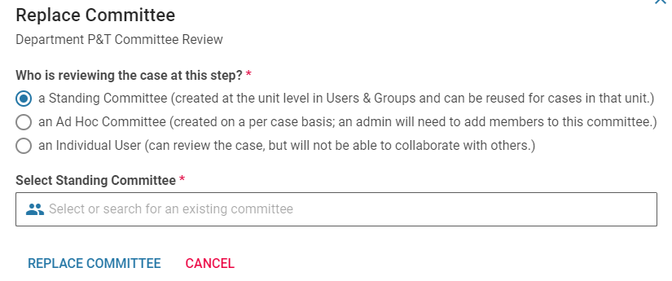

1. In the **“Select Standing Committee”** section select the committee from your unit to replace the current committee and then click **“Replace Committee”**
   1. For ease of use, please use **“a Standing Committee”** for the replacement of any University Template committees.
2. The new committee is now on that step and will include any users assigned to the respective committee.

**Reconsideration of a “Case” – Deans Level Only**

1. Once logged into Interfolio, the left side of the dashboard will have a list of Modules (Faculty180; Faculty Search; Review, Promotion and Tenure)
2. Under Review, Promotion and Tenure click on **“Cases”.**



1. On the Case list, click the name of the case for which reconsideration is needed.



1. On the Case Materials tab of the Case page, select the Dean’s recommendation to send to the Department Head.
   1. You can also select any other materials from the case to add as supporting documentation to the Dean’s recommendation.



1. Selecting materials will open the blue action bar.
2. Click “Share”



1. Select “With Committee Members”.

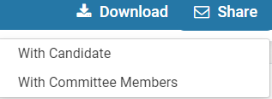

1. Next, you will be able to indicate who should receive the shared files.
2. Select “User” to be able to send back to the Department Head

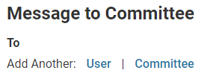

1. Indicate who should receive the shared files by searching for the Department Head and clicking “Add User”.
2. Type your custom message.
3. Select files from the case as needed.

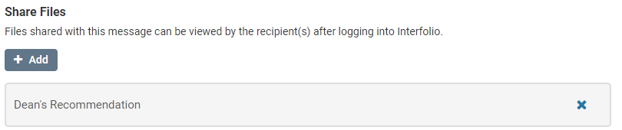

1. On the upper right-hand side of your message, click "Enable File Response" so that the Department Head will be able to respond.
2. Enter a message reason, and a deadline.

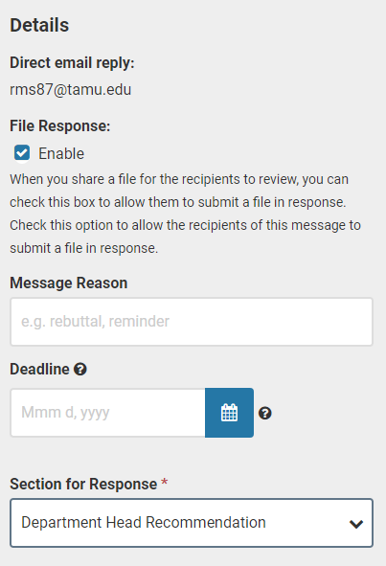

1. Select the internal case section “Department Head Recommendation” as the section for the response to be uploaded to.
2. When the response comes in, the file will appear in the section indicated.
3. Once the response has been received, the case can be sent to the College P&T committee for re-review.
4. Upon re-review by the College P&T committee, the case would be sent forward to the Dean to upload their final recommendation.